Data in OFFICES

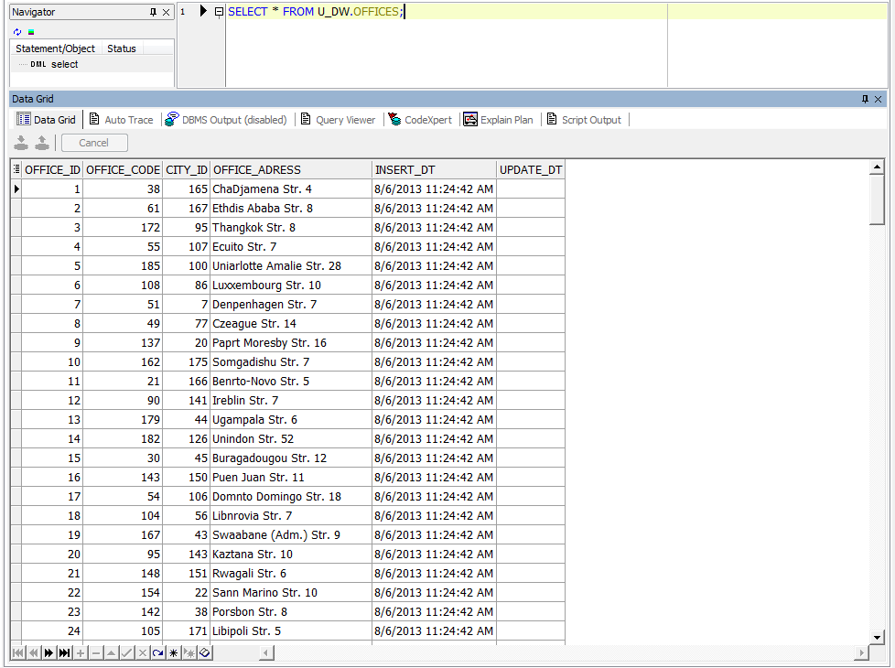

Data in EMPLOYEES

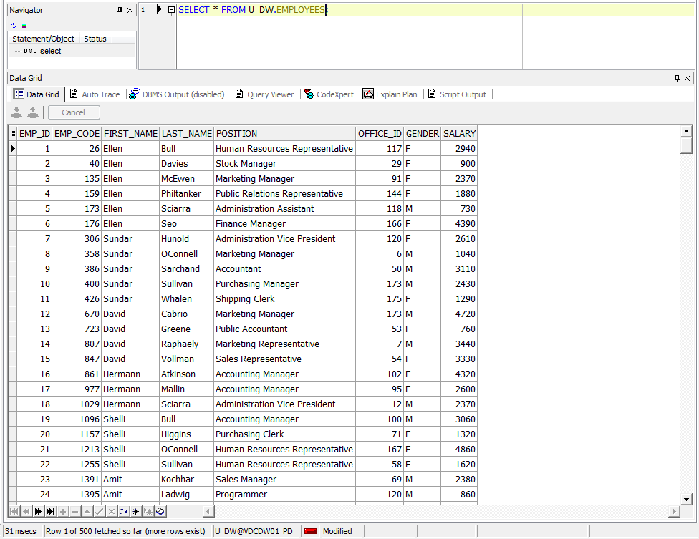

Data in CUSTOMERS

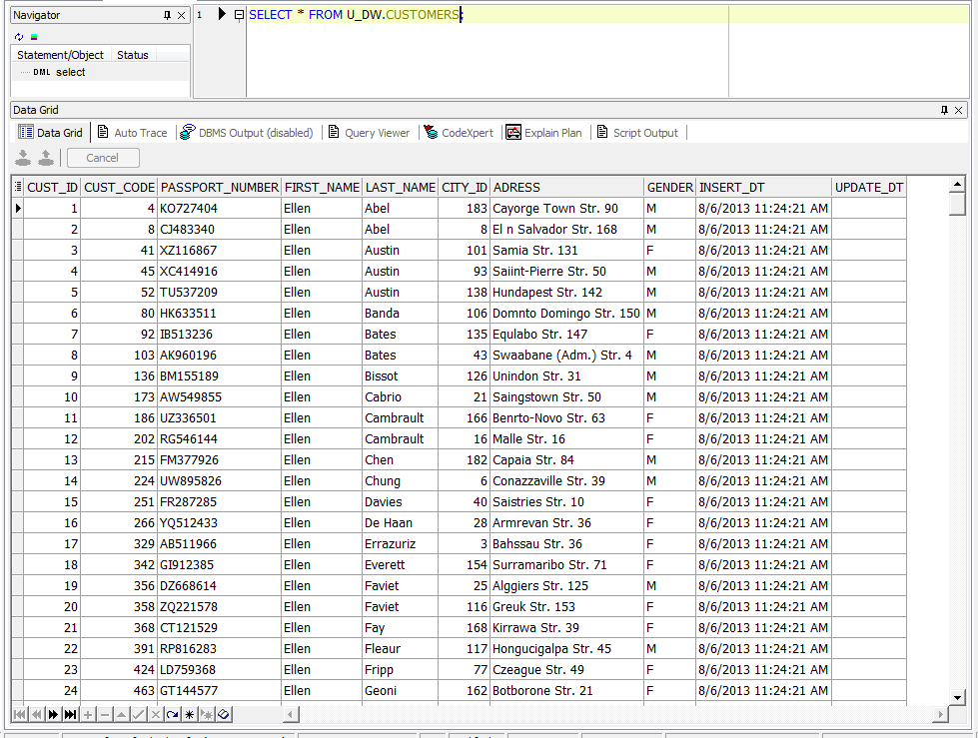

Test data for consistent.

Table OFFICES

( SELECT office_code

, city_id

, office_adress

FROM u_dw.offices

MINUS

SELECT DISTINCT emp.office_id

, ct.city_id

, emp.adress

FROM u_sa_data.tmp_employees emp JOIN u_dw.cities ct ON ( emp.office_city = ct.city_desc ) )

UNION ALL

( SELECT DISTINCT emp.office_id

, ct.city_id

, emp.adress

FROM u_sa_data.tmp_employees emp JOIN u_dw.cities ct ON ( emp.office_city = ct.city_desc )

MINUS

SELECT office_code

, city_id

, office_adress

FROM u_dw.offices );

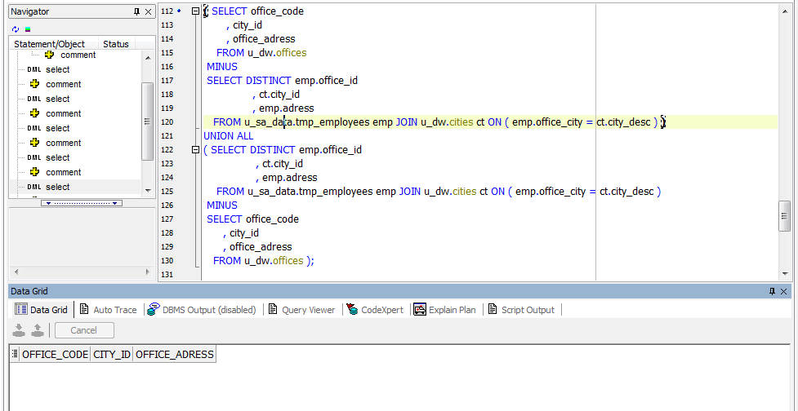

Table EMPLOYEES

( SELECT emp_code

, first_name

, last_name

, position

, office_id

, gender

, salary

FROM u_dw.employees

MINUS

SELECT emp.emp_id

, emp.first_name

, emp.last_name

, emp.position

, o.office_id

, emp.gender

, emp.salary

FROM u_sa_data.tmp_employees emp JOIN u_dw.offices o ON ( emp.office_id = o.office_code ) )

UNION ALL

( SELECT emp.emp_id

, emp.first_name

, emp.last_name

, emp.position

, o.office_id

, emp.gender

, emp.salary

FROM u_sa_data.tmp_employees emp JOIN u_dw.offices o ON ( emp.office_id = o.office_code )

MINUS

SELECT emp_code

, first_name

, last_name

, position

, office_id

, gender

, salary

FROM u_dw.employees );

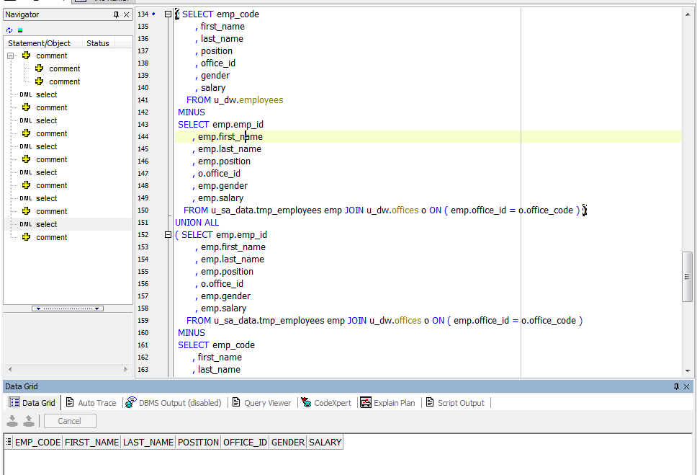

Table CUSTOMERS

( SELECT cust_code

, passport_number

, first_name

, last_name

, city_id

, adress

, gender

FROM u_dw.customers

MINUS

SELECT cust.cust_id

, cust.passport_number

, cust.first_name

, cust.last_name

, ct.city_id

, cust.adress

, cust.gender

FROM u_sa_data.tmp_customers cust JOIN u_dw.cities ct ON ( cust.city = ct.city_desc ) )

UNION ALL

( SELECT cust.cust_id

, cust.passport_number

, cust.first_name

, cust.last_name

, ct.city_id

, cust.adress

, cust.gender

FROM u_sa_data.tmp_customers cust JOIN u_dw.cities ct ON ( cust.city = ct.city_desc )

MINUS

SELECT cust_code

, passport_number

, first_name

, last_name

, city_id

, adress

, gender

FROM u_dw.customers );

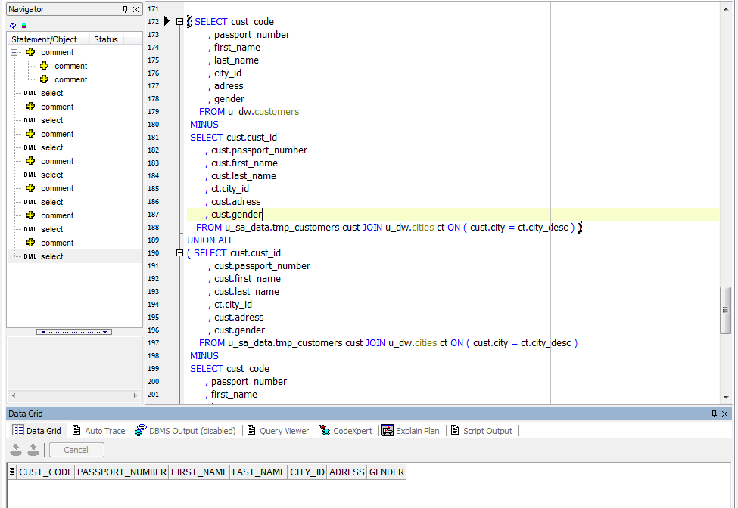

After repeated execution of the packages all tables in the U_DW scheme have not changed.

CREATE Monthly Reports Layouts.

